The Parish Church of St Andrew
Orford with Longford

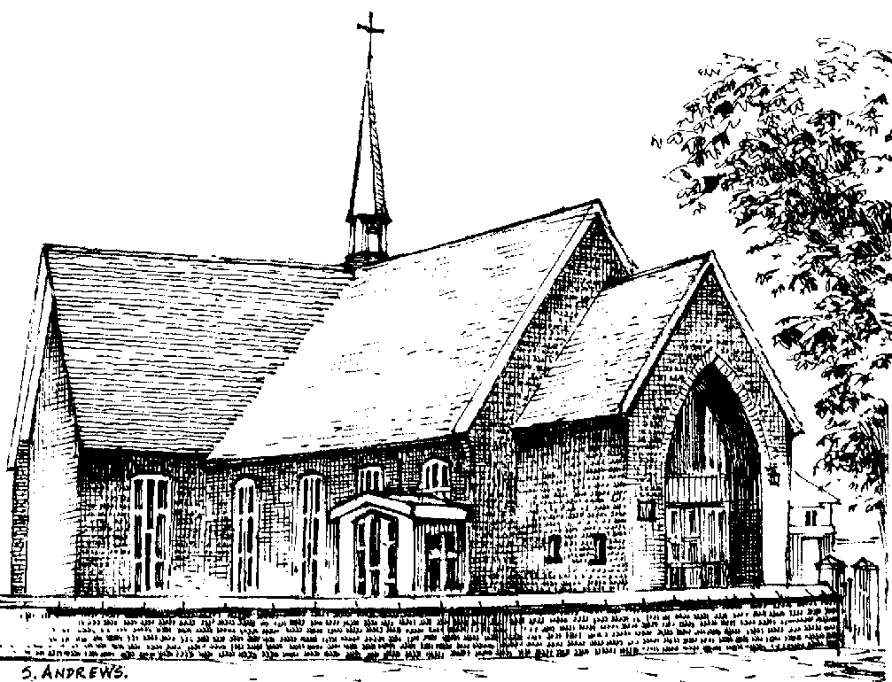

Gladys Hendry
1925 - 2007

Friday 19th October 2007

Order of Service

ALL STAND as the funeral procession enters the church. Once the family are seated, please SIT.

The procession enters to Amazing Grace played by Glynis and Brian Radford on organ and bagpipes.

Introduction

Priest: “Jesus said, ‘I am the resurrection and I am the life; they who believe in me, though they die, yet shall they live, and whoever lives and believes in me shall never die.’” (John 11. 25, 26)

We meet in the name of Jesus Christ, who died and was raised to the glory of God the Father. Grace and mercy be with you. Amen.

The priest introduces the service

Priest: Let us pray:

Almighty God, you judge us with infinite mercy and justice, and love everything you have made. In your mercy turn the darkness of death into the dawn of new life, and the sorrow of parting into the joy of heaven; through our Saviour, Jesus Christ. Amen

All: Merciful Father, hear our prayers and comfort us; renew our trust in your Son, whom you raised from the dead; strengthen our faith that all who have died in the love of Christ will share in his resurrection; who lives and reigns with you, in the unity of the Holy Spirit, one God, now and for ever. Amen

The Ministry of the Word

Hymn: “Glad that I live am I” (please stand)

Glad that I live am I; that the sky is blue;
Glad for the country lanes, and the fall of dew.

After the sun the rain, after the rain the sun;
This is the way of life, till the work be done.

All that we need to do, be we low or high,
Is to see that we grow nearer the sky.
The First Reading (based on Eccl. 3.1ff)

Take time to think – it is the source of power.
Take time to read – it is the foundation of wisdom.
Take time to play – it is the secret of staying young.
Take time to be quiet – it is the opportunity to seek God.

Take time to be aware – it is the opportunity to help others.
Take time to love and be loved – it is God’s greatest gift.

Take time to laugh – it is the music of the soul.
Take time to be friendly – it is the road to happiness.

Take time to dream – it is what the future is made of.
Take time to pray – it is the greatest power on earth.

The Address

A Verse
Do not stand at my grave and weep,
I am not there, I do not sleep.
I am in a thousand winds that blow
I am the softly falling snow.
I am the gentle showers of rain,
I am the fields of ripening grain.
I am in the morning rush,
I am in the graceful rush
of beautiful birds in circling flight.
I am the starshine of the night.
I am in the flowers that bloom,
I am in a quiet room.
I am in the birds that sing,
I am in each lovely thing.
Do not stand at my grave and cry,
I am not there, I did not die.
(Mary Frye 1932)

The Prayers:

Priest: God of mercy, Lord of life, you have made us in your image to reflect your truth and light: we give you thanks for Gladys, for the grace and mercy she received from you, for all that was good in her life, and especially for the memories we treasure today.

Lord, in your mercy
All: hear our prayer.

Priest: You promised eternal life to those who believe. Remember for good this your daughter Gladys as we also remember her. Bring all who rest in Christ, including Ernie and Karen and those we bring to mind this morning, into the fullness of your kingdom where sins have been forgiven and death is no more.

Lord, in your mercy
All: hear our prayer.

Priest: Your mighty power brings joy out of grief and life out of death. Look in mercy on Glynis, Janet and Kathy, their families and all who mourn at this time. Give them patient faith in times of darkness. Strengthen them with the knowledge of your love.

Lord, in your mercy
All: hear our prayer.

Priest: Father, you are tender towards your children and your mercy is over all your works. Heal the memories of hurt and failure. Give us the wisdom and grace to use aright the time that is left to us here on earth, to turn to Christ and follow in his steps in the way that leads to everlasting life.

Lord, in your mercy
All: hear our prayer.

God of mercy, entrusting into your hands all that you have made and rejoicing in our communion with all your faithful people, we make our prayers through Jesus Christ our Saviour. Amen.

Priest: Let us pray with confidence as our Saviour has taught us
All: Our Father, who art in heaven, hallowed be thy name; thy kingdom come; thy will be done; on earth as it is in heaven. Give us this day our daily bread. And forgive us our trespasses, as we forgive those who trespass against us. And lead us not into temptation; but deliver us from evil. For thine is the kingdom, the power and the glory, for ever and ever. Amen.

Hymn: “Guide me O thou great Redeemer”

Guide me, O thou great Redeemer,
pilgrim through this barren land;
I am weak, but thou art mighty;
hold me with thy powerful hand:
bread of heaven,
feed me now and evermore.

Open now the crystal fountain
whence the healing stream doth flow;
let the fiery cloudy pillar
lead me all my journey through;
strong deliverer,
be thou still my strength and shield.

When I tread the verge of Jordan,
bid my anxious fears subside;
death of death, and hells destruction,
land me safe on Canaan's side:
songs and praises
I will ever give to thee.

Commendation and Farewell [please remain standing]

Priest: Let us commend Gladys to the mercy of God our Maker and Redeemer.

The coffin is sprinkled with holy water taken from the font

Priest: With this water we call to mind Gladys’ baptism. As Christ went through the deep waters of death for us, so may he bring us to the fullness of resurrection life with Gladys and all the redeemed.

God our creator and redeemer, by your power Christ conquered death and entered into glory. Confident of his victory and claiming his promises, we entrust Gladys to your mercy in the name of Jesus our Lord, who died and is alive and reigns with you, now and for ever. Amen

All: Heavenly Father, in your Son Jesus Christ you have given us a true faith and a sure hope. Strengthen this faith and hope in us all our days, that we may live as those who believe in the communion of saints, the forgiveness of sins and the resurrection to eternal life; through Jesus Christ our Lord. Amen.

Priest: May the road rise up to meet you.
May the wind always be at your back.
May the sun shine warm upon your face,
and the rain fall soft upon your feet,
until we meet again, may you be held
in the hollow of God’s hand. Amen

The procession leaves church to Handel’s “March” from Judas Maccabaeus played on organ and bombarde.

The Committal follows the service in Church, and will take place at Walton Lea crematorium at 12.00 noon. Those who wish to join Gladys’ family at Walton Lea are welcome to do so.

There will be a reception / buffet in the Hall after the service and everyone is warmly invited. If you prefer not to travel to Walton Lea, please feel free to go straight to the Hall after the church service where there will be tea or coffee available. It is hoped that you will stay for the buffet to be served when the family return.

The Committal (at Walton Lea)

Opening sentence and introduction:

Words from Psalm 121:

I lift up my eyes to the hills:
but where shall I find help?
Our help comes from the Lord:
who has made heaven and earth.
The Lord will defend you from all evil,
it is he who will guard your life.
The Lord will defend your going out and your coming in
from this time forwards and for evermore.

A prayer for Gladys: Remember O Lord your daughter Gladys who has gone before us with the sign of faith, and now rests in the sleep of peace. According to your promises, grant to her and to all who rest in Christ, refreshment, light and peace; through the same Jesus Christ our Lord. Amen

The Committal: We have entrusted our sister Gladys to God's mercy, and we now commit her body to be cremated: in sure and certain hope of the resurrection to eternal life through our Lord Jesus Christ, who died, was buried, and rose again for us. To him be glory for ever. Amen

A prayer for Gladys’ family and friends: Almighty God, Father of all mercies and giver of all comfort: deal graciously, we pray, with those who mourn, that casting all their care on you, they may know the consolation of your love; through Jesus Christ our Lord. Amen

The Blessing: May God give you his comfort and his peace, his light and his joy, in this world and the next; and the blessing of God almighty, the Father, the Son, and the Holy Spirit, be among you and remain with you always. Amen


Acknowledgement: Common Worship: Pastoral Services, material from which is included in this service, is copyright © The Archbishops’ Council (2000-2002)
